Influence of circadian rhythms on motor activity of hens
Vyacheslav Shcherbatov¹, Denis Osepchuk², and Yulia Petrenko¹
¹Kuban State Agrarian University named after I.T. Trubilin, 350044, Krasnodar, Russian Federation
²Krasnodar Research Centre for Animal Husbandry and Veterinary Medicine, 350055, Krasnodar, Russian Federation

Abstract. The paper analyzes the characteristic features of the manifestation of circadian rhythms of particular forms of motor activity in chickens. A genetically determined bimodal profile of aggressive, forage and sexual activity of birds during the daytime was established. Correlations between different forms of activity, their frequency and the influence of the time of switching on the lighting and the length of daylight hours in the room on the rhythms of their manifestation have been determined. On the basis of the studies carried out, the authors propose modes of feeding chickens according to their biological rhythms to reduce aggressiveness and increase sexual activity in the herd in order to increase the efficiency of the production of poultry products.

Introduction. The strategic task of modern egg poultry farming is to obtain maximum productivity by increasing egg production, viability and fertility of poultry in conditions of intensive exploitation.
If knowledge about homeostasis and synthetic processes in the body of poultry has long been used in practical zootechnics …
Materials and Methods. Aggression in poultry is judged by the number of aggressive acts in its behavior and the ability to dominate other individuals…
The number of behavioral acts was recorded every five minutes. Observations were carried out during two adjacent days from the moment the lighting in the house was turned on and until the light was turned off (table 1).

Table 1. Light regime for keeping hens and roosters
Chicken age, days | Light on-off time, h | Duration of daylight hours, h | Illumination, lx
113-142 | 8-16 | 8 | 10
143- 154 | 9-16 | 8 | 10
155-161 | 8-17 | 9 | 15
162-168 | 7-17 | 10 | 15
169-175 | 6-17 | 11 | 20
176-182 | 5-18 | 13 | 20
183-210 | 5-19 | 14 | 20
211-240 | 5-20 | 15 | 30
241-270 | 4-20 | 16 | 30
271-300 | 4-21 | 17 | 30

Results and Discussion. The aggressiveness of males varies not only with age, but also fluctuates during daylight hours. The most intensely aggressive …
Table 2 shows …

Table 2. Aggressiveness of males during the day depending on age (M ± m)
Age,  days | Rooster aggression | Hours of the day |  |  |  |  |  |  |  |  |  |  |  |  |  |  |  | Daily total
 |  | 5 | 6 | 7 | 8 | 9 | 10 | 11 | 12 | 13 | 14 | 15 | 16 | 17 | 18 | 19 | 20
150 | Number of aggressive acts | - | - | - | - | 16 | 9 | 12 | 9 | 8 | 9 | 9 | 22 | - | - | - | - | 94
 | of all aggression,% | - | - | - | - | 17.0 | 9.6 | 12.8 | 9.6 | 8.5 | 9.6 | 9.6 | 23.3 | - | - | - | - | 100
180 | Number of aggressive acts |  | 66 | 62 | 42 | 51 | 45 | 41 | 34 | 24 | 30 | 33 | 55 | 32 | 181 | 87 |  | 783
 | of all aggression,% |  | 8.43 | 7.92 | 5.36 | 6.51 | 5.75 | 5.24 | 4.34 | 3.07 | 3.83 | 4.22 | 7.02 | 4.09 | 23.1 | 11.1 |  | 100
240 | Number of aggressive acts | 73 | 48 | 30 | 20 | 25 | 33 | 57 | 27 | 27 | 34 | 46 | 37 | 63 | 83 | 143 | 134 | 880
 | of all aggression,% | 8.3 | 5.45 | 3.41 | 2.27 | 2.84 | 3.75 | 6.48 | 3.07 | 3.07 | 3.86 | 5.23 | 4.2 | 7.16 | 9.43 | 16.25 | 15.2 | 100
Figure 2 shows a graph of changes in the feeding activity …

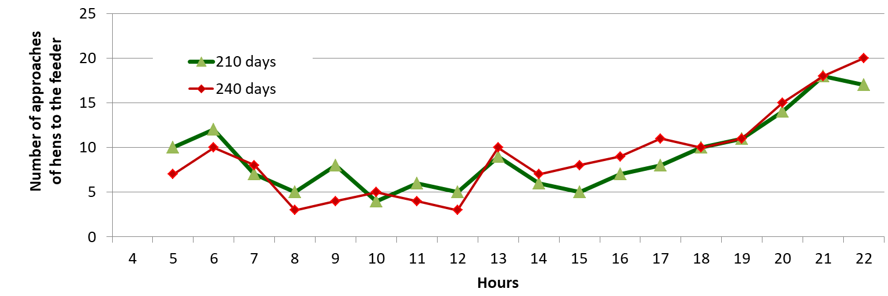
Fig. 2. Rhythms of feeding activity of chickens during the photoperiod with free access to feed

The use of a time-differentiated feeding regime increases the correlation between feeding and sexual activity of birds. The correlation coefficient between these signs for the whole day increased in comparison with the control and amounted to r = +0.26 at 190 days and r = +0.6 at 240 days [19].
Conclusions:
1. Circadian rhythms of aggressive, sexual and forage activity of birds, being particular forms of motor activity, have a bimodal profile and depend …

References:
- J.W. Graber, A.V. Nalbandov, Biol. Reprod, 14, 109-114 (1976)
- D. Wood-Gush, A. Gilbert, British Poultry Sci., 10, 29-36 (1969)
- N. Stack, J.M. Zeitzer, Ch. Czeisler, C.D. Behn, Journal of Biological Rhythms, 35(1), 195-206 (2019) https://doi.org/10.1177/0748730419886992
- Woller, G. Didier, Journal of Biological Rhythms, 28(6), 390-402 (2013) DOI: 10.1177/0748730413512454
- G.P. Dunster, L. de la Iglesia, M. Ben-Hamo, C. Nave et al., Science Advances, 4(12), eaau620012 (2018) DOI: 10.1126/sciadv.aau6200
- C.I. Eastman, V.A. Tomaka, S.J. Crowley, Scientific Reports. 6:36716 (2016) https://doi.org/10.1038/srep36716
- J.J. Gooley, Ann Acad Med Singapore, 37(8), 669-676 (2008)
- T. Roenneberg, A. Wirz-Justice, M. Merrow, Journal of Biological Rhythms, 18, 80-90 (2003) https://doi.org/10.1177/0748730402239679
- T. Komai, S. Wearden, Poultry Sci., 38, 356-359 (1959)
- H.B. Siegel, Poultry Sci., 42, 1046- 1048 (1960)
- R. Hajnd, Povedenie zhivotnyh (Moskow), 858 (1975)
- J. Aschoff, Proc. 14-th Int. Orn. Congr., 81-105 (1966)
- A.E. Eynon, Condor, 63, 269-293 (1961)
- E. Gwinner, Vogelwarte, 23, 1-4 (1975)
- H. Tebbe Verena, H. Boqner, Bayer Landwirt, 63(2), 219-242 (1986)
- V.I. Shherbatov, Novye priemy povyshenija plodovitosti kur mjasnyh porod pri kletochnom soderzhanii: avtoref. diss… d-ra s.-h. nauk (Krasnodar), 48 (1992)
- I.L. Gal'pern, Sb. trudov Pushkinskoj nauchno-issled. laboratorii razvedenija s.-h. zhivotnyh. (Pushkin), 8, 230–240 (1958)
- Z.I. Duhno, Ocenka plemennyh kachestv petuhov po ih polovoj skorospelosti i aktivnosti: avtoref. dis... kand. s.-h. nauk (Pushkin), 20, (1965)
- V.I. Shherbatov, Ptica i pticeprodukty, 3, 58-60 (2016)

